1 run......

training 1 epoch...

3.962871551513672 seconds used......

1 training finished! average train loss: 2.51267830063315

total clf loss: 20.938111901283264 total adv loss: 10.888709634542465

evaluating...

Confusion matrix, without normalization

[[ 20 12 9]

[ 59 20 16]

[290 129 295]]

Normalized confusion matrix

[[0.48780488 0.29268293 0.2195122 ]

[0.62105263 0.21052632 0.16842105]

[0.40616246 0.18067227 0.41316527]]

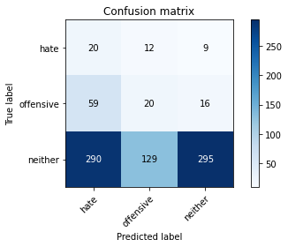

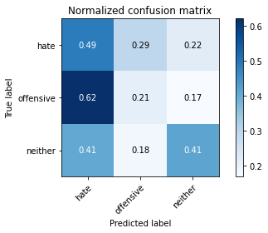

precision recall f1-score support

hate 0.05 0.49 0.10 41

offensive 0.12 0.21 0.16 95

neither 0.92 0.41 0.57 714

accuracy 0.39 850

macro avg 0.37 0.37 0.27 850

weighted avg 0.79 0.39 0.50 850

average eval_loss: 1.13705033202504, accuracy: 0.3941176470588235

training 2 epoch...

3.9520130157470703 seconds used......

2 training finished! average train loss: 2.3012318330652572

total clf loss: 18.50409758090973 total adv loss: 10.30842188000679

evaluating...

Confusion matrix, without normalization

[[ 24 15 2]

[ 70 15 10]

[370 103 241]]

Normalized confusion matrix

[[0.58536585 0.36585366 0.04878049]

[0.73684211 0.15789474 0.10526316]

[0.51820728 0.1442577 0.33753501]]

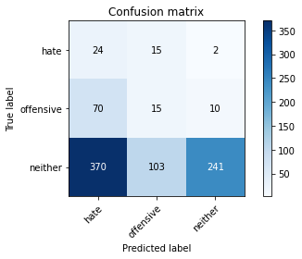

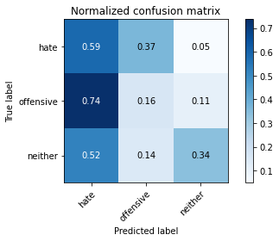

precision recall f1-score support

hate 0.05 0.59 0.10 41

offensive 0.11 0.16 0.13 95

neither 0.95 0.34 0.50 714

accuracy 0.33 850

macro avg 0.37 0.36 0.24 850

weighted avg 0.82 0.33 0.44 850

average eval_loss: 1.1328562331754108, accuracy: 0.32941176470588235

training 3 epoch...

4.003911018371582 seconds used......

3 training finished! average train loss: 2.0437001831391277

total clf loss: 17.063591837882996 total adv loss: 8.8396555185318

evaluating...

Confusion matrix, without normalization

[[ 13 20 8]

[ 22 36 37]

[176 177 361]]

Normalized confusion matrix

[[0.31707317 0.48780488 0.19512195]

[0.23157895 0.37894737 0.38947368]

[0.2464986 0.24789916 0.50560224]]

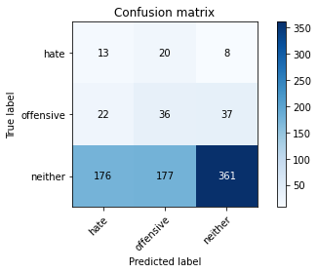

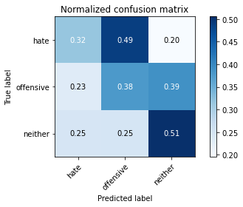

precision recall f1-score support

hate 0.06 0.32 0.10 41

offensive 0.15 0.38 0.22 95

neither 0.89 0.51 0.64 714

accuracy 0.48 850

macro avg 0.37 0.40 0.32 850

weighted avg 0.77 0.48 0.57 850

average eval_loss: 1.0291173194730006, accuracy: 0.4823529411764706

training 4 epoch...

3.9472320079803467 seconds used......

4 training finished! average train loss: 1.5907661143471212

total clf loss: 14.948448121547699 total adv loss: 6.047288045287132

evaluating...

Confusion matrix, without normalization

[[ 22 15 4]

[ 32 41 22]

[240 188 286]]

Normalized confusion matrix

[[0.53658537 0.36585366 0.09756098]

[0.33684211 0.43157895 0.23157895]

[0.33613445 0.26330532 0.40056022]]

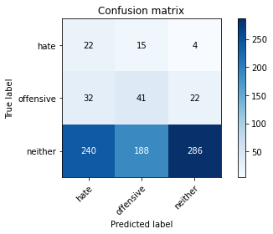

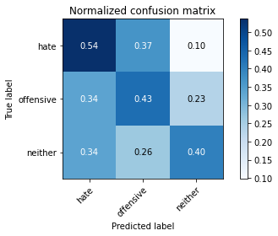

precision recall f1-score support

hate 0.07 0.54 0.13 41

offensive 0.17 0.43 0.24 95

neither 0.92 0.40 0.56 714

accuracy 0.41 850

macro avg 0.39 0.46 0.31 850

weighted avg 0.79 0.41 0.50 850

average eval_loss: 1.1009339905062387, accuracy: 0.41058823529411764

training 5 epoch...

3.957976818084717 seconds used......

5 training finished! average train loss: 0.9911375326268813

total clf loss: 11.432282149791718 total adv loss: 2.7085280790925026

evaluating...

Confusion matrix, without normalization

[[ 26 9 6]

[ 28 22 45]

[213 145 356]]

Normalized confusion matrix

[[0.63414634 0.2195122 0.14634146]

[0.29473684 0.23157895 0.47368421]

[0.29831933 0.20308123 0.49859944]]

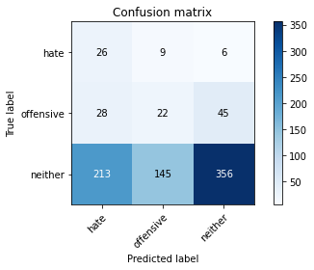

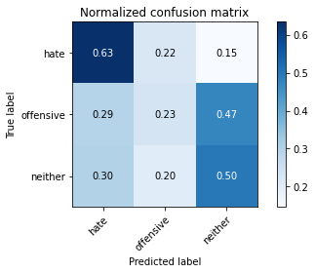

precision recall f1-score support

hate 0.10 0.63 0.17 41

offensive 0.12 0.23 0.16 95

neither 0.87 0.50 0.64 714

accuracy 0.48 850

macro avg 0.37 0.45 0.32 850

weighted avg 0.75 0.48 0.56 850

average eval_loss: 1.0476204323214153, accuracy: 0.4752941176470588

training 6 epoch...

4.089051008224487 seconds used......

6 training finished! average train loss: 0.6271705382010516

total clf loss: 8.752753287553787 total adv loss: 0.9545729225501418

evaluating...

Confusion matrix, without normalization

[[ 22 8 11]

[ 24 19 52]

[182 117 415]]

Normalized confusion matrix

[[0.53658537 0.19512195 0.26829268]

[0.25263158 0.2 0.54736842]

[0.25490196 0.16386555 0.58123249]]

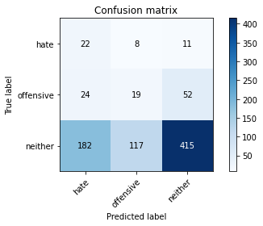

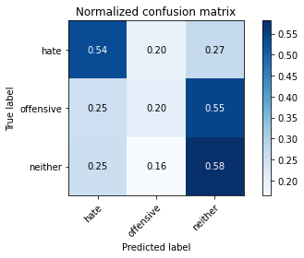

precision recall f1-score support

hate 0.10 0.54 0.16 41

offensive 0.13 0.20 0.16 95

neither 0.87 0.58 0.70 714

accuracy 0.54 850

macro avg 0.37 0.44 0.34 850

weighted avg 0.75 0.54 0.61 850

average eval_loss: 0.9840968218307162, accuracy: 0.5364705882352941

training 7 epoch...

3.9605233669281006 seconds used......

7 training finished! average train loss: 0.40699360475820656

total clf loss: 6.3376263082027435 total adv loss: 0.2906325124204159

evaluating...

Confusion matrix, without normalization

[[ 25 8 8]

[ 37 17 41]

[258 102 354]]

Normalized confusion matrix

[[0.6097561 0.19512195 0.19512195]

[0.38947368 0.17894737 0.43157895]

[0.36134454 0.14285714 0.49579832]]

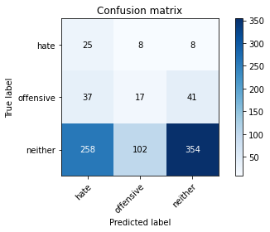

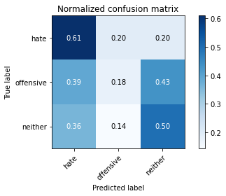

precision recall f1-score support

hate 0.08 0.61 0.14 41

offensive 0.13 0.18 0.15 95

neither 0.88 0.50 0.63 714

accuracy 0.47 850

macro avg 0.36 0.43 0.31 850

weighted avg 0.76 0.47 0.56 850

average eval_loss: 1.1748095023077587, accuracy: 0.46588235294117647

training 8 epoch...

4.0003273487091064 seconds used......

8 training finished! average train loss: 0.29471077726167794

total clf loss: 4.444888591766357 total adv loss: 0.2825973020226229

evaluating...

Confusion matrix, without normalization

[[ 28 6 7]

[ 39 12 44]

[286 94 334]]

Normalized confusion matrix

[[0.68292683 0.14634146 0.17073171]

[0.41052632 0.12631579 0.46315789]

[0.40056022 0.13165266 0.46778711]]

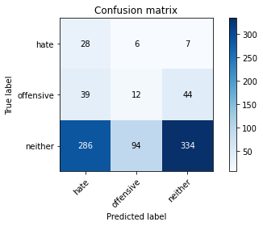

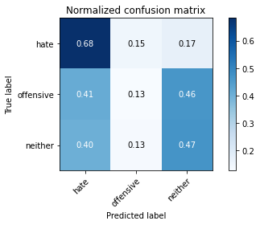

precision recall f1-score support

hate 0.08 0.68 0.14 41

offensive 0.11 0.13 0.12 95

neither 0.87 0.47 0.61 714

accuracy 0.44 850

macro avg 0.35 0.43 0.29 850

weighted avg 0.74 0.44 0.53 850

average eval_loss: 1.32125479086887, accuracy: 0.44

training 9 epoch...

3.986229419708252 seconds used......

9 training finished! average train loss: 0.20861679578528686

total clf loss: 3.350424900650978 total adv loss: 0.09803031626506709

evaluating...

Confusion matrix, without normalization

[[ 27 6 8]

[ 31 12 52]

[222 99 393]]

Normalized confusion matrix

[[0.65853659 0.14634146 0.19512195]

[0.32631579 0.12631579 0.54736842]

[0.31092437 0.13865546 0.55042017]]

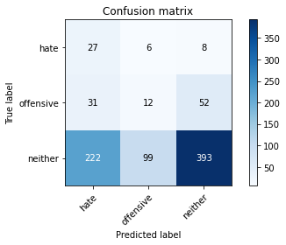

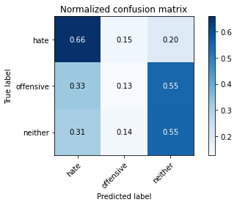

precision recall f1-score support

hate 0.10 0.66 0.17 41

offensive 0.10 0.13 0.11 95

neither 0.87 0.55 0.67 714

accuracy 0.51 850

macro avg 0.36 0.45 0.32 850

weighted avg 0.74 0.51 0.59 850

average eval_loss: 1.2656484623981077, accuracy: 0.508235294117647

training 10 epoch...

3.9573824405670166 seconds used......

10 training finished! average train loss: 0.12330191056517993

total clf loss: 2.086185246706009 total adv loss: 0.00497361977249966

evaluating...

Confusion matrix, without normalization

[[ 27 7 7]

[ 29 23 43]

[203 157 354]]

Normalized confusion matrix

[[0.65853659 0.17073171 0.17073171]

[0.30526316 0.24210526 0.45263158]

[0.28431373 0.21988796 0.49579832]]

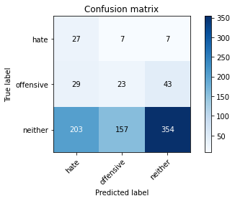

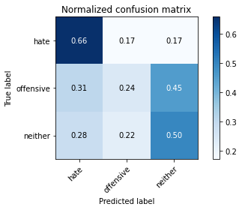

precision recall f1-score support

hate 0.10 0.66 0.18 41

offensive 0.12 0.24 0.16 95

neither 0.88 0.50 0.63 714

accuracy 0.48 850

macro avg 0.37 0.47 0.33 850

weighted avg 0.75 0.48 0.56 850

average eval_loss: 1.399393541868343, accuracy: 0.4752941176470588

2 run......

training 1 epoch...

3.966315269470215 seconds used......

1 training finished! average train loss: 2.5078650923336254

total clf loss: 20.928539514541626 total adv loss: 10.852583229541779

evaluating...

Confusion matrix, without normalization

[[ 14 19 8]

[ 26 26 43]

[210 195 309]]

Normalized confusion matrix

[[0.34146341 0.46341463 0.19512195]

[0.27368421 0.27368421 0.45263158]

[0.29411765 0.27310924 0.43277311]]

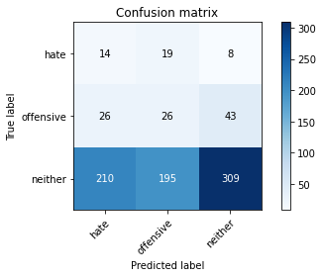

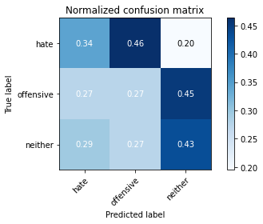

precision recall f1-score support

hate 0.06 0.34 0.10 41

offensive 0.11 0.27 0.16 95

neither 0.86 0.43 0.58 714

accuracy 0.41 850

macro avg 0.34 0.35 0.28 850

weighted avg 0.74 0.41 0.51 850

average eval_loss: 1.1197826044504033, accuracy: 0.41058823529411764

training 2 epoch...

3.972184181213379 seconds used......

2 training finished! average train loss: 2.2676814303678623

total clf loss: 18.271198213100433 total adv loss: 10.139693021774292

evaluating...

Confusion matrix, without normalization

[[ 10 25 6]

[ 23 50 22]

[186 245 283]]

Normalized confusion matrix

[[0.24390244 0.6097561 0.14634146]

[0.24210526 0.52631579 0.23157895]

[0.2605042 0.34313725 0.39635854]]

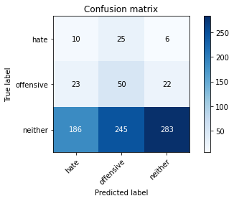

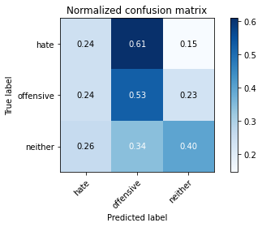

precision recall f1-score support

hate 0.05 0.24 0.08 41

offensive 0.16 0.53 0.24 95

neither 0.91 0.40 0.55 714

accuracy 0.40 850

macro avg 0.37 0.39 0.29 850

weighted avg 0.78 0.40 0.49 850

average eval_loss: 1.0957578337469767, accuracy: 0.40352941176470586

training 3 epoch...

3.983942985534668 seconds used......

3 training finished! average train loss: 2.1670359583461987

total clf loss: 17.23518842458725 total adv loss: 9.802211284637451

evaluating...

Confusion matrix, without normalization

[[ 6 31 4]

[ 8 72 15]

[107 324 283]]

Normalized confusion matrix

[[0.14634146 0.75609756 0.09756098]

[0.08421053 0.75789474 0.15789474]

[0.14985994 0.45378151 0.39635854]]

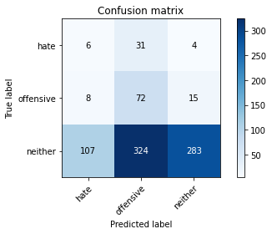

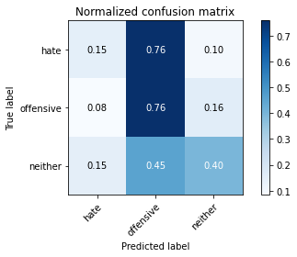

precision recall f1-score support

hate 0.05 0.15 0.07 41

offensive 0.17 0.76 0.28 95

neither 0.94 0.40 0.56 714

accuracy 0.42 850

macro avg 0.39 0.43 0.30 850

weighted avg 0.81 0.42 0.50 850

average eval_loss: 1.0892397996991179, accuracy: 0.42470588235294116

training 4 epoch...

3.9580209255218506 seconds used......

4 training finished! average train loss: 1.8400974413927864

total clf loss: 15.465503454208374 total adv loss: 7.90807643532753

evaluating...

Confusion matrix, without normalization

[[ 13 22 6]

[ 24 49 22]

[189 203 322]]

Normalized confusion matrix

[[0.31707317 0.53658537 0.14634146]

[0.25263158 0.51578947 0.23157895]

[0.26470588 0.28431373 0.45098039]]

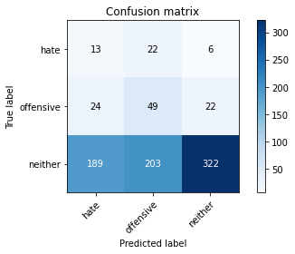

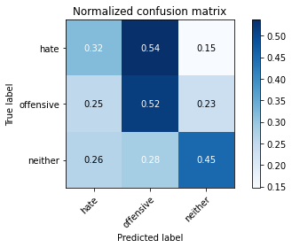

precision recall f1-score support

hate 0.06 0.32 0.10 41

offensive 0.18 0.52 0.27 95

neither 0.92 0.45 0.61 714

accuracy 0.45 850

macro avg 0.39 0.43 0.32 850

weighted avg 0.80 0.45 0.54 850

average eval_loss: 1.0509046198323715, accuracy: 0.45176470588235296

training 5 epoch...

3.949894428253174 seconds used......

5 training finished! average train loss: 1.3356301994884716

total clf loss: 12.695547997951508 total adv loss: 5.005082838237286

evaluating...

Confusion matrix, without normalization

[[ 21 14 6]

[ 44 22 29]

[288 109 317]]

Normalized confusion matrix

[[0.51219512 0.34146341 0.14634146]

[0.46315789 0.23157895 0.30526316]

[0.40336134 0.15266106 0.44397759]]

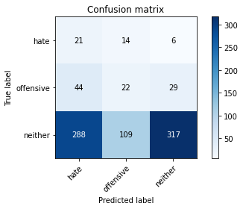

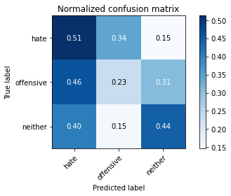

precision recall f1-score support

hate 0.06 0.51 0.11 41

offensive 0.15 0.23 0.18 95

neither 0.90 0.44 0.59 714

accuracy 0.42 850

macro avg 0.37 0.40 0.29 850

weighted avg 0.78 0.42 0.53 850

average eval_loss: 1.050646149834921, accuracy: 0.4235294117647059

training 6 epoch...

4.0495285987854 seconds used......

6 training finished! average train loss: 0.8113628801177529

total clf loss: 9.765242785215378 total adv loss: 2.0139630660414696

evaluating...

Confusion matrix, without normalization

[[ 15 19 7]

[ 21 50 24]

[181 195 338]]

Normalized confusion matrix

[[0.36585366 0.46341463 0.17073171]

[0.22105263 0.52631579 0.25263158]

[0.2535014 0.27310924 0.47338936]]

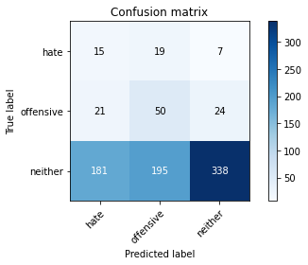

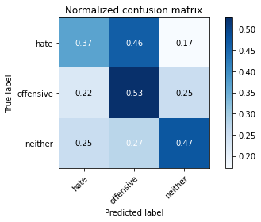

precision recall f1-score support

hate 0.07 0.37 0.12 41

offensive 0.19 0.53 0.28 95

neither 0.92 0.47 0.62 714

accuracy 0.47 850

macro avg 0.39 0.46 0.34 850

weighted avg 0.79 0.47 0.56 850

average eval_loss: 1.0348772229843362, accuracy: 0.47411764705882353

training 7 epoch...

3.967660427093506 seconds used......

7 training finished! average train loss: 0.6054788424688227

total clf loss: 7.579986155033112 total adv loss: 1.3565771393477917

evaluating...

Confusion matrix, without normalization

[[ 16 15 10]

[ 18 39 38]

[151 145 418]]

Normalized confusion matrix

[[0.3902439 0.36585366 0.24390244]

[0.18947368 0.41052632 0.4 ]

[0.21148459 0.20308123 0.58543417]]

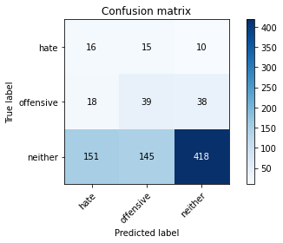

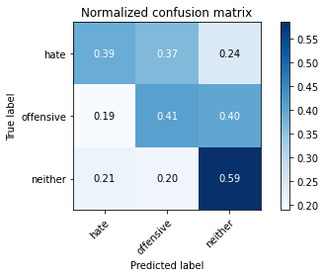

precision recall f1-score support

hate 0.09 0.39 0.14 41

offensive 0.20 0.41 0.27 95

neither 0.90 0.59 0.71 714

accuracy 0.56 850

macro avg 0.39 0.46 0.37 850

weighted avg 0.78 0.56 0.63 850

average eval_loss: 0.9379475889510887, accuracy: 0.5564705882352942

training 8 epoch...

3.9553515911102295 seconds used......

8 training finished! average train loss: 0.35115843923652873

total clf loss: 5.394813314080238 total adv loss: 0.28744007309433073

evaluating...

Confusion matrix, without normalization

[[ 26 8 7]

[ 39 14 42]

[245 91 378]]

Normalized confusion matrix

[[0.63414634 0.19512195 0.17073171]

[0.41052632 0.14736842 0.44210526]

[0.34313725 0.12745098 0.52941176]]

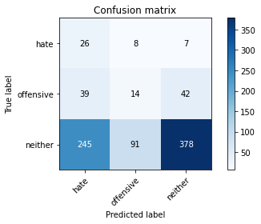

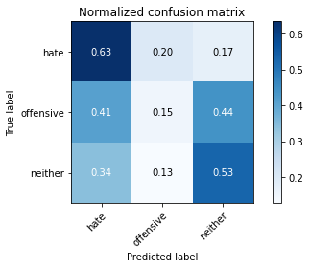

precision recall f1-score support

hate 0.08 0.63 0.15 41

offensive 0.12 0.15 0.13 95

neither 0.89 0.53 0.66 714

accuracy 0.49 850

macro avg 0.36 0.44 0.32 850

weighted avg 0.76 0.49 0.58 850

average eval_loss: 1.076383226832678, accuracy: 0.49176470588235294

training 9 epoch...

3.9491050243377686 seconds used......

9 training finished! average train loss: 0.2363057636162814

total clf loss: 3.9372953921556473 total adv loss: 0.03995129780378193

evaluating...

Confusion matrix, without normalization

[[ 20 14 7]

[ 31 36 28]

[201 176 337]]

Normalized confusion matrix

[[0.48780488 0.34146341 0.17073171]

[0.32631579 0.37894737 0.29473684]

[0.28151261 0.2464986 0.4719888 ]]

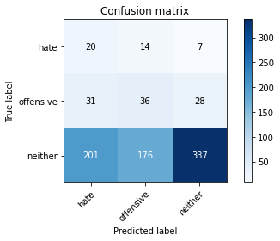

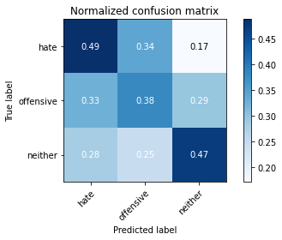

precision recall f1-score support

hate 0.08 0.49 0.14 41

offensive 0.16 0.38 0.22 95

neither 0.91 0.47 0.62 714

accuracy 0.46 850

macro avg 0.38 0.45 0.33 850

weighted avg 0.78 0.46 0.55 850

average eval_loss: 1.1931590593831485, accuracy: 0.4623529411764706

training 10 epoch...

4.098841190338135 seconds used......

10 training finished! average train loss: 0.1610931973246967

total clf loss: 2.7166017964482307 total adv loss: 0.010991272822138853

evaluating...

Confusion matrix, without normalization

[[ 28 7 6]

[ 39 19 37]

[266 108 340]]

Normalized confusion matrix

[[0.68292683 0.17073171 0.14634146]

[0.41052632 0.2 0.38947368]

[0.37254902 0.1512605 0.47619048]]

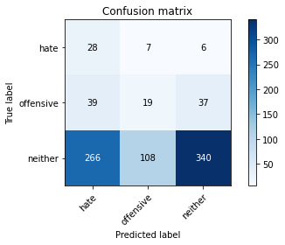

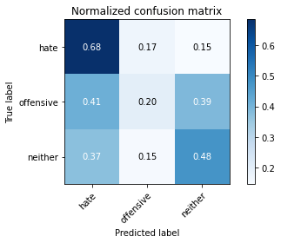

precision recall f1-score support

hate 0.08 0.68 0.15 41

offensive 0.14 0.20 0.17 95

neither 0.89 0.48 0.62 714

accuracy 0.46 850

macro avg 0.37 0.45 0.31 850

weighted avg 0.77 0.46 0.55 850

average eval_loss: 1.3148259584640347, accuracy: 0.45529411764705885

3 run......

training 1 epoch...

4.002763986587524 seconds used......

1 training finished! average train loss: 2.581983397988712

total clf loss: 21.540618896484375 total adv loss: 11.176549434661865

evaluating...

Confusion matrix, without normalization

[[ 29 10 2]

[ 65 8 22]

[246 202 266]]

Normalized confusion matrix

[[0.70731707 0.24390244 0.04878049]

[0.68421053 0.08421053 0.23157895]

[0.34453782 0.28291317 0.37254902]]

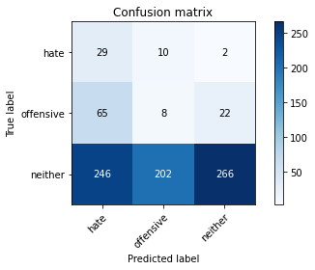

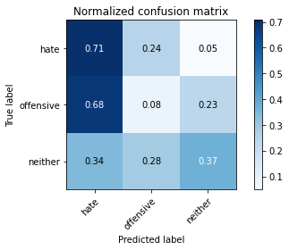

precision recall f1-score support

hate 0.09 0.71 0.15 41

offensive 0.04 0.08 0.05 95

neither 0.92 0.37 0.53 714

accuracy 0.36 850

macro avg 0.35 0.39 0.24 850

weighted avg 0.78 0.36 0.46 850

average eval_loss: 1.1288656370584356, accuracy: 0.3564705882352941

training 2 epoch...

3.9589364528656006 seconds used......

2 training finished! average train loss: 2.325087947003982

total clf loss: 18.152372121810913 total adv loss: 10.687061369419098

evaluating...

Confusion matrix, without normalization

[[ 8 32 1]

[ 12 61 22]

[ 70 382 262]]

Normalized confusion matrix

[[0.19512195 0.7804878 0.02439024]

[0.12631579 0.64210526 0.23157895]

[0.09803922 0.53501401 0.36694678]]

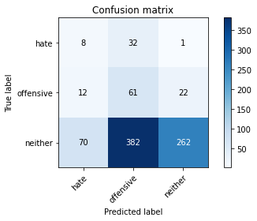

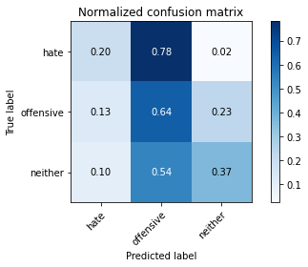

precision recall f1-score support

hate 0.09 0.20 0.12 41

offensive 0.13 0.64 0.21 95

neither 0.92 0.37 0.52 714

accuracy 0.39 850

macro avg 0.38 0.40 0.29 850

weighted avg 0.79 0.39 0.47 850

average eval_loss: 1.082141991271529, accuracy: 0.38941176470588235

training 3 epoch...

3.9614107608795166 seconds used......

3 training finished! average train loss: 2.0752093511469223

total clf loss: 16.533881723880768 total adv loss: 9.372338503599167

evaluating...

Confusion matrix, without normalization

[[ 23 17 1]

[ 36 43 16]

[199 278 237]]

Normalized confusion matrix

[[0.56097561 0.41463415 0.02439024]

[0.37894737 0.45263158 0.16842105]

[0.27871148 0.38935574 0.33193277]]

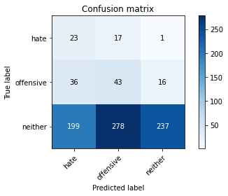

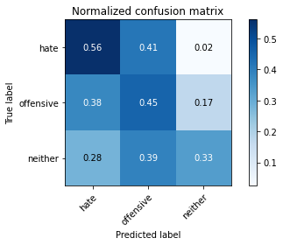

precision recall f1-score support

hate 0.09 0.56 0.15 41

offensive 0.13 0.45 0.20 95

neither 0.93 0.33 0.49 714

accuracy 0.36 850

macro avg 0.38 0.45 0.28 850

weighted avg 0.80 0.36 0.44 850

average eval_loss: 1.0990328005580015, accuracy: 0.3564705882352941

training 4 epoch...

4.025905132293701 seconds used......

4 training finished! average train loss: 1.650448385406943

total clf loss: 14.018739759922028 total adv loss: 7.019441306591034

evaluating...

Confusion matrix, without normalization

[[ 29 8 4]

[ 43 27 25]

[243 164 307]]

Normalized confusion matrix

[[0.70731707 0.19512195 0.09756098]

[0.45263158 0.28421053 0.26315789]

[0.34033613 0.22969188 0.42997199]]

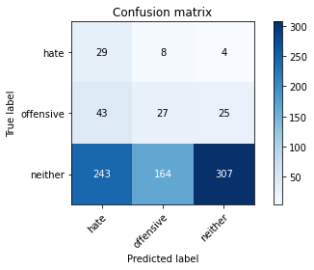

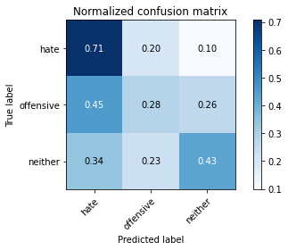

precision recall f1-score support

hate 0.09 0.71 0.16 41

offensive 0.14 0.28 0.18 95

neither 0.91 0.43 0.58 714

accuracy 0.43 850

macro avg 0.38 0.47 0.31 850

weighted avg 0.79 0.43 0.52 850

average eval_loss: 1.0525736316691998, accuracy: 0.42705882352941177

training 5 epoch...

3.9534401893615723 seconds used......

5 training finished! average train loss: 1.1630472014932072

total clf loss: 10.92488580942154 total adv loss: 4.423458278179169

evaluating...

Confusion matrix, without normalization

[[ 21 16 4]

[ 14 72 9]

[153 320 241]]

Normalized confusion matrix

[[0.51219512 0.3902439 0.09756098]

[0.14736842 0.75789474 0.09473684]

[0.21428571 0.44817927 0.33753501]]

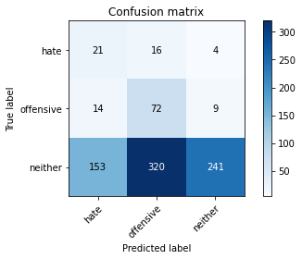

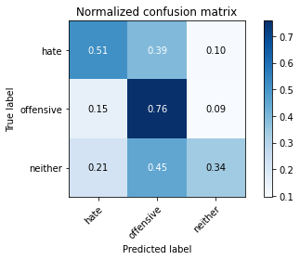

precision recall f1-score support

hate 0.11 0.51 0.18 41

offensive 0.18 0.76 0.29 95

neither 0.95 0.34 0.50 714

accuracy 0.39 850

macro avg 0.41 0.54 0.32 850

weighted avg 0.82 0.39 0.46 850

average eval_loss: 1.1445185784683671, accuracy: 0.39294117647058824

training 6 epoch...

3.955531120300293 seconds used......

6 training finished! average train loss: 0.9936355878325069

total clf loss: 8.748270392417908 total adv loss: 4.0717673525214195

evaluating...

Confusion matrix, without normalization

[[ 32 5 4]

[ 39 16 40]

[262 124 328]]

Normalized confusion matrix

[[0.7804878 0.12195122 0.09756098]

[0.41052632 0.16842105 0.42105263]

[0.36694678 0.17366947 0.45938375]]

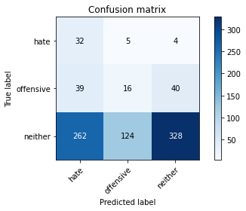

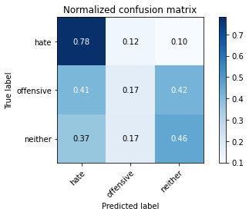

precision recall f1-score support

hate 0.10 0.78 0.17 41

offensive 0.11 0.17 0.13 95

neither 0.88 0.46 0.60 714

accuracy 0.44 850

macro avg 0.36 0.47 0.30 850

weighted avg 0.76 0.44 0.53 850

average eval_loss: 1.103826752235723, accuracy: 0.4423529411764706

training 7 epoch...

4.005363464355469 seconds used......

7 training finished! average train loss: 0.5585435716544881

total clf loss: 6.202969521284103 total adv loss: 1.6461356319487095

evaluating...

Confusion matrix, without normalization

[[ 26 11 4]

[ 23 34 38]

[184 187 343]]

Normalized confusion matrix

[[0.63414634 0.26829268 0.09756098]

[0.24210526 0.35789474 0.4 ]

[0.25770308 0.26190476 0.48039216]]

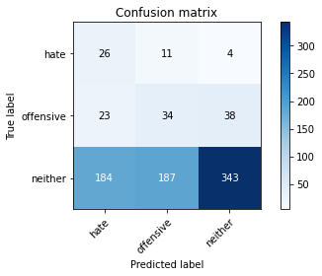

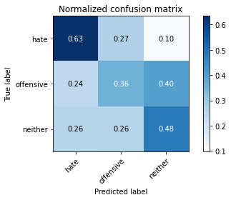

precision recall f1-score support

hate 0.11 0.63 0.19 41

offensive 0.15 0.36 0.21 95

neither 0.89 0.48 0.62 714

accuracy 0.47 850

macro avg 0.38 0.49 0.34 850

weighted avg 0.77 0.47 0.56 850

average eval_loss: 1.0659206968753836, accuracy: 0.47411764705882353

training 8 epoch...

3.947082757949829 seconds used......

8 training finished! average train loss: 0.25371166055693345

total clf loss: 4.008579142391682 total adv loss: 0.15225953387562186

evaluating...

Confusion matrix, without normalization

[[ 30 7 4]

[ 26 36 33]

[214 190 310]]

Normalized confusion matrix

[[0.73170732 0.17073171 0.09756098]

[0.27368421 0.37894737 0.34736842]

[0.29971989 0.26610644 0.43417367]]

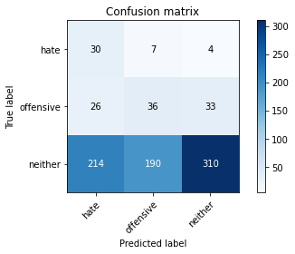

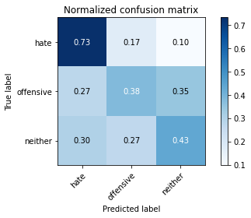

precision recall f1-score support

hate 0.11 0.73 0.19 41

offensive 0.15 0.38 0.22 95

neither 0.89 0.43 0.58 714

accuracy 0.44 850

macro avg 0.39 0.51 0.33 850

weighted avg 0.77 0.44 0.52 850

average eval_loss: 1.244438382428746, accuracy: 0.4423529411764706

training 9 epoch...

3.9524800777435303 seconds used......

9 training finished! average train loss: 0.17274574497166803

total clf loss: 2.862994506955147 total adv loss: 0.03684158535907045

evaluating...

Confusion matrix, without normalization

[[ 30 7 4]

[ 21 39 35]

[197 188 329]]

Normalized confusion matrix

[[0.73170732 0.17073171 0.09756098]

[0.22105263 0.41052632 0.36842105]

[0.27591036 0.26330532 0.46078431]]

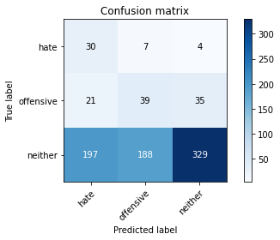

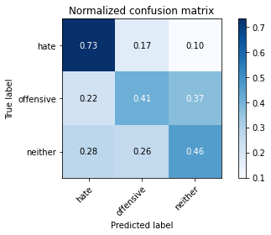

precision recall f1-score support

hate 0.12 0.73 0.21 41

offensive 0.17 0.41 0.24 95

neither 0.89 0.46 0.61 714

accuracy 0.47 850

macro avg 0.39 0.53 0.35 850

weighted avg 0.78 0.47 0.55 850

average eval_loss: 1.2541514331864756, accuracy: 0.4682352941176471

training 10 epoch...

3.9694912433624268 seconds used......

10 training finished! average train loss: 0.11406384298906606

total clf loss: 1.909687951207161 total adv loss: 0.014698690793011338

evaluating...

Confusion matrix, without normalization

[[ 27 7 7]

[ 18 36 41]

[148 162 404]]

Normalized confusion matrix

[[0.65853659 0.17073171 0.17073171]

[0.18947368 0.37894737 0.43157895]

[0.20728291 0.22689076 0.56582633]]

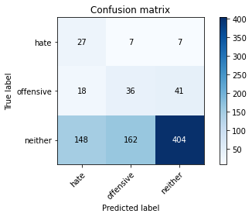

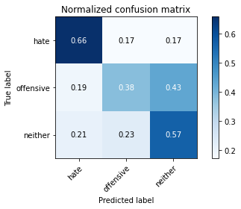

precision recall f1-score support

hate 0.14 0.66 0.23 41

offensive 0.18 0.38 0.24 95

neither 0.89 0.57 0.69 714

accuracy 0.55 850

macro avg 0.40 0.53 0.39 850

weighted avg 0.78 0.55 0.62 850

average eval_loss: 1.0994443919856187, accuracy: 0.5494117647058824

4 run......

training 1 epoch...

4.029160022735596 seconds used......

1 training finished! average train loss: 2.4768252653234146

total clf loss: 20.415116548538208 total adv loss: 10.845456331968307

evaluating...

Confusion matrix, without normalization

[[ 22 10 9]

[ 52 9 34]

[304 81 329]]

Normalized confusion matrix

[[0.53658537 0.24390244 0.2195122 ]

[0.54736842 0.09473684 0.35789474]

[0.42577031 0.11344538 0.46078431]]

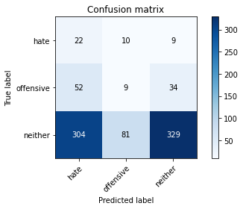

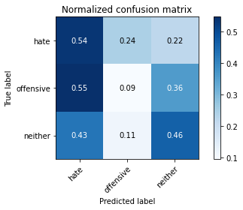

precision recall f1-score support

hate 0.06 0.54 0.11 41

offensive 0.09 0.09 0.09 95

neither 0.88 0.46 0.61 714

accuracy 0.42 850

macro avg 0.34 0.36 0.27 850

weighted avg 0.76 0.42 0.52 850

average eval_loss: 1.0880339963491572, accuracy: 0.4235294117647059

training 2 epoch...

3.9786179065704346 seconds used......

2 training finished! average train loss: 2.316969534930061

total clf loss: 18.050890684127808 total adv loss: 10.668795704841614

evaluating...

Confusion matrix, without normalization

[[ 13 25 3]

[ 45 40 10]

[273 223 218]]

Normalized confusion matrix

[[0.31707317 0.6097561 0.07317073]

[0.47368421 0.42105263 0.10526316]

[0.38235294 0.31232493 0.30532213]]

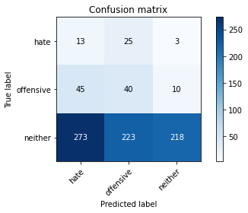

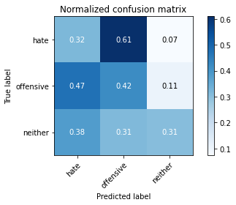

precision recall f1-score support

hate 0.04 0.32 0.07 41

offensive 0.14 0.42 0.21 95

neither 0.94 0.31 0.46 714

accuracy 0.32 850

macro avg 0.37 0.35 0.25 850

weighted avg 0.81 0.32 0.41 850

average eval_loss: 1.1073100954987283, accuracy: 0.31882352941176473

training 3 epoch...

3.954195022583008 seconds used......

3 training finished! average train loss: 2.063625020139358

total clf loss: 17.135528683662415 total adv loss: 8.973048150539398

evaluating...

Confusion matrix, without normalization

[[ 20 16 5]

[ 41 37 17]

[300 156 258]]

Normalized confusion matrix

[[0.48780488 0.3902439 0.12195122]

[0.43157895 0.38947368 0.17894737]

[0.42016807 0.21848739 0.36134454]]

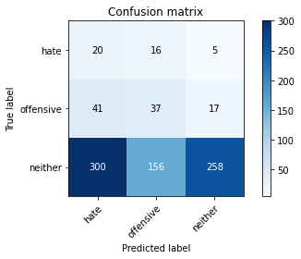

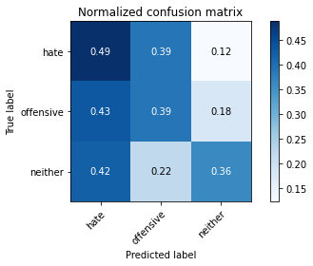

precision recall f1-score support

hate 0.06 0.49 0.10 41

offensive 0.18 0.39 0.24 95

neither 0.92 0.36 0.52 714

accuracy 0.37 850

macro avg 0.38 0.41 0.29 850

weighted avg 0.80 0.37 0.47 850

average eval_loss: 1.0754597256349963, accuracy: 0.37058823529411766

training 4 epoch...

3.9825611114501953 seconds used......

4 training finished! average train loss: 1.6934258026235245

total clf loss: 15.15082049369812 total adv loss: 6.818709284067154

evaluating...

Confusion matrix, without normalization

[[ 13 22 6]

[ 10 67 18]

[156 249 309]]

Normalized confusion matrix

[[0.31707317 0.53658537 0.14634146]

[0.10526316 0.70526316 0.18947368]

[0.21848739 0.3487395 0.43277311]]

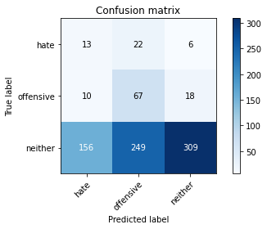

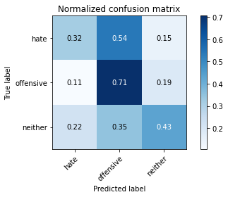

precision recall f1-score support

hate 0.07 0.32 0.12 41

offensive 0.20 0.71 0.31 95

neither 0.93 0.43 0.59 714

accuracy 0.46 850

macro avg 0.40 0.49 0.34 850

weighted avg 0.81 0.46 0.54 850

average eval_loss: 1.0100720684195674, accuracy: 0.4576470588235294

training 5 epoch...

3.94551944732666 seconds used......

5 training finished! average train loss: 1.2729107702479643

total clf loss: 12.405325472354889 total adv loss: 4.617078952491283

evaluating...

Confusion matrix, without normalization

[[ 22 16 3]

[ 27 63 5]

[253 239 222]]

Normalized confusion matrix

[[0.53658537 0.3902439 0.07317073]

[0.28421053 0.66315789 0.05263158]

[0.35434174 0.33473389 0.31092437]]

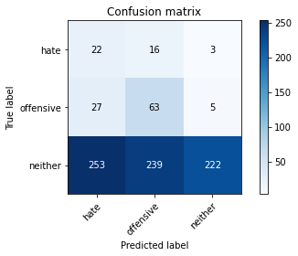

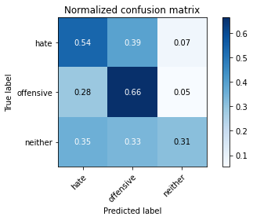

precision recall f1-score support

hate 0.07 0.54 0.13 41

offensive 0.20 0.66 0.31 95

neither 0.97 0.31 0.47 714

accuracy 0.36 850

macro avg 0.41 0.50 0.30 850

weighted avg 0.84 0.36 0.44 850

average eval_loss: 1.1948953333289125, accuracy: 0.3611764705882353

training 6 epoch...

3.9436137676239014 seconds used......

6 training finished! average train loss: 0.8219253561075996

total clf loss: 9.896218031644821 total adv loss: 2.0382565427571535

evaluating...

Confusion matrix, without normalization

[[ 26 12 3]

[ 39 38 18]

[291 165 258]]

Normalized confusion matrix

[[0.63414634 0.29268293 0.07317073]

[0.41052632 0.4 0.18947368]

[0.40756303 0.23109244 0.36134454]]

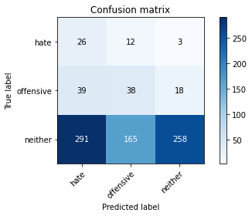

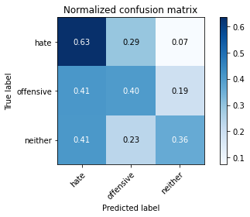

precision recall f1-score support

hate 0.07 0.63 0.13 41

offensive 0.18 0.40 0.25 95

neither 0.92 0.36 0.52 714

accuracy 0.38 850

macro avg 0.39 0.47 0.30 850

weighted avg 0.80 0.38 0.47 850

average eval_loss: 1.1894679419523062, accuracy: 0.3788235294117647

training 7 epoch...

4.0108723640441895 seconds used......

7 training finished! average train loss: 0.5422223070088554

total clf loss: 7.933262974023819 total adv loss: 0.6422581779770553

evaluating...

Confusion matrix, without normalization

[[ 14 15 12]

[ 7 47 41]

[113 169 432]]

Normalized confusion matrix

[[0.34146341 0.36585366 0.29268293]

[0.07368421 0.49473684 0.43157895]

[0.15826331 0.23669468 0.60504202]]

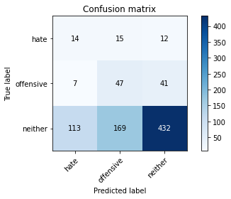

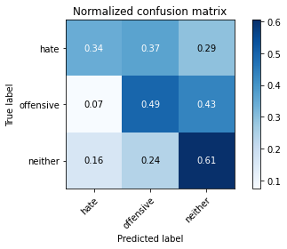

precision recall f1-score support

hate 0.10 0.34 0.16 41

offensive 0.20 0.49 0.29 95

neither 0.89 0.61 0.72 714

accuracy 0.58 850

macro avg 0.40 0.48 0.39 850

weighted avg 0.78 0.58 0.65 850

average eval_loss: 0.9059285351703333, accuracy: 0.58

training 8 epoch...

3.979182004928589 seconds used......

8 training finished! average train loss: 0.3180806268663967

total clf loss: 5.284714981913567 total adv loss: 0.06132783539942466

evaluating...

Confusion matrix, without normalization

[[ 23 13 5]

[ 32 42 21]

[251 155 308]]

Normalized confusion matrix

[[0.56097561 0.31707317 0.12195122]

[0.33684211 0.44210526 0.22105263]

[0.35154062 0.21708683 0.43137255]]

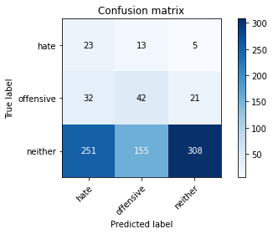

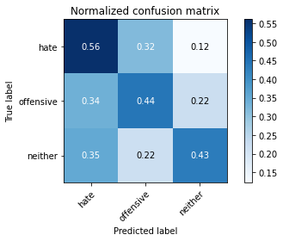

precision recall f1-score support

hate 0.08 0.56 0.13 41

offensive 0.20 0.44 0.28 95

neither 0.92 0.43 0.59 714

accuracy 0.44 850

macro avg 0.40 0.48 0.33 850

weighted avg 0.80 0.44 0.53 850

average eval_loss: 1.2197835604811824, accuracy: 0.4388235294117647

training 9 epoch...

3.9482717514038086 seconds used......

9 training finished! average train loss: 0.2255267189706073

total clf loss: 3.754028357565403 total adv loss: 0.03996292903320864

evaluating...

Confusion matrix, without normalization

[[ 23 11 7]

[ 33 27 35]

[231 115 368]]

Normalized confusion matrix

[[0.56097561 0.26829268 0.17073171]

[0.34736842 0.28421053 0.36842105]

[0.32352941 0.16106443 0.51540616]]

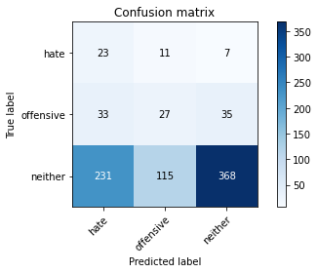

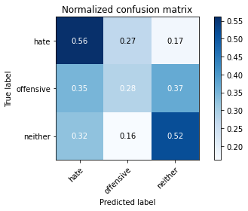

precision recall f1-score support

hate 0.08 0.56 0.14 41

offensive 0.18 0.28 0.22 95

neither 0.90 0.52 0.65 714

accuracy 0.49 850

macro avg 0.38 0.45 0.34 850

weighted avg 0.78 0.49 0.58 850

average eval_loss: 1.1777435612193374, accuracy: 0.49176470588235294

training 10 epoch...

3.953119993209839 seconds used......

10 training finished! average train loss: 0.15842923806870685

total clf loss: 2.6751538552343845 total adv loss: 0.009071602777112275

evaluating...

Confusion matrix, without normalization

[[ 21 13 7]

[ 22 39 34]

[200 159 355]]

Normalized confusion matrix

[[0.51219512 0.31707317 0.17073171]

[0.23157895 0.41052632 0.35789474]

[0.28011204 0.22268908 0.49719888]]

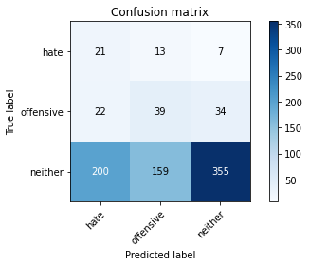

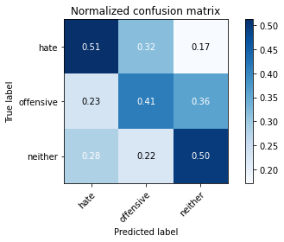

precision recall f1-score support

hate 0.09 0.51 0.15 41

offensive 0.18 0.41 0.25 95

neither 0.90 0.50 0.64 714

accuracy 0.49 850

macro avg 0.39 0.47 0.35 850

weighted avg 0.78 0.49 0.57 850

average eval_loss: 1.274255602685518, accuracy: 0.48823529411764705

5 run......

training 1 epoch...

3.975207567214966 seconds used......

1 training finished! average train loss: 2.5799404312582577

total clf loss: 22.004715085029602 total adv loss: 10.927136242389679

evaluating...

Confusion matrix, without normalization

[[ 25 10 6]

[ 27 23 45]

[343 76 295]]

Normalized confusion matrix

[[0.6097561 0.24390244 0.14634146]

[0.28421053 0.24210526 0.47368421]

[0.48039216 0.10644258 0.41316527]]

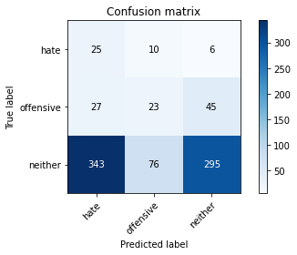

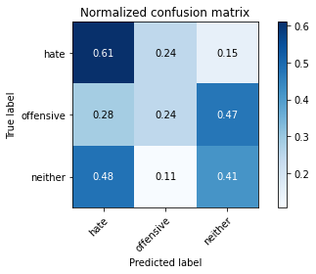

precision recall f1-score support

hate 0.06 0.61 0.11 41

offensive 0.21 0.24 0.23 95

neither 0.85 0.41 0.56 714

accuracy 0.40 850

macro avg 0.38 0.42 0.30 850

weighted avg 0.74 0.40 0.50 850

average eval_loss: 1.1395511710366537, accuracy: 0.40352941176470586

training 2 epoch...

3.996095895767212 seconds used......

2 training finished! average train loss: 2.281243730993832

total clf loss: 18.41385245323181 total adv loss: 10.183645755052567

evaluating...

Confusion matrix, without normalization

[[ 11 27 3]

[ 18 56 21]

[191 227 296]]

Normalized confusion matrix

[[0.26829268 0.65853659 0.07317073]

[0.18947368 0.58947368 0.22105263]

[0.267507 0.31792717 0.41456583]]

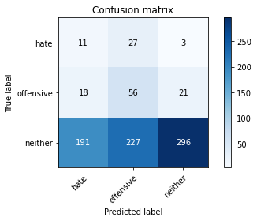

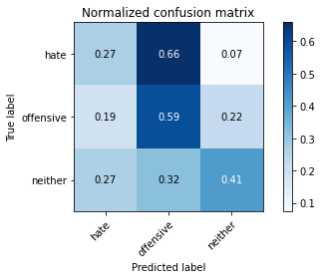

precision recall f1-score support

hate 0.05 0.27 0.08 41

offensive 0.18 0.59 0.28 95

neither 0.93 0.41 0.57 714

accuracy 0.43 850

macro avg 0.39 0.42 0.31 850

weighted avg 0.80 0.43 0.52 850

average eval_loss: 1.089908059253249, accuracy: 0.42705882352941177

training 3 epoch...

3.9497034549713135 seconds used......

3 training finished! average train loss: 2.0474599529715145

total clf loss: 16.95868945121765 total adv loss: 8.924064755439758

evaluating...

Confusion matrix, without normalization

[[ 14 25 2]

[ 18 72 5]

[218 281 215]]

Normalized confusion matrix

[[0.34146341 0.6097561 0.04878049]

[0.18947368 0.75789474 0.05263158]

[0.30532213 0.39355742 0.30112045]]

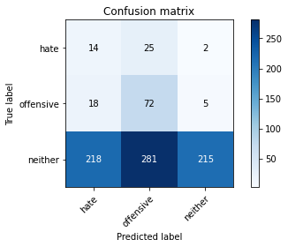

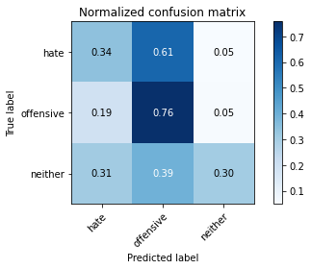

precision recall f1-score support

hate 0.06 0.34 0.10 41

offensive 0.19 0.76 0.30 95

neither 0.97 0.30 0.46 714

accuracy 0.35 850

macro avg 0.40 0.47 0.29 850

weighted avg 0.84 0.35 0.42 850

average eval_loss: 1.144154741320499, accuracy: 0.35411764705882354

training 4 epoch...

3.9631385803222656 seconds used......

4 training finished! average train loss: 1.6760644211488611

total clf loss: 14.826313495635986 total adv loss: 6.8333907425403595

evaluating...

Confusion matrix, without normalization

[[ 24 13 4]

[ 28 32 35]

[267 147 300]]

Normalized confusion matrix

[[0.58536585 0.31707317 0.09756098]

[0.29473684 0.33684211 0.36842105]

[0.37394958 0.20588235 0.42016807]]

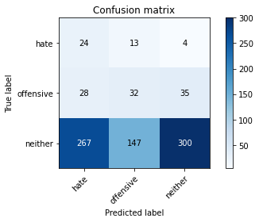

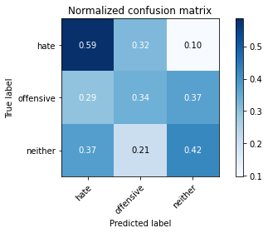

precision recall f1-score support

hate 0.08 0.59 0.13 41

offensive 0.17 0.34 0.22 95

neither 0.88 0.42 0.57 714

accuracy 0.42 850

macro avg 0.38 0.45 0.31 850

weighted avg 0.77 0.42 0.51 850

average eval_loss: 1.0635638874630595, accuracy: 0.4188235294117647

training 5 epoch...

4.0795722007751465 seconds used......

5 training finished! average train loss: 1.1225638249341179

total clf loss: 12.374347805976868 total adv loss: 3.354618553072214

evaluating...

Confusion matrix, without normalization

[[ 21 16 4]

[ 28 49 18]

[216 218 280]]

Normalized confusion matrix

[[0.51219512 0.3902439 0.09756098]

[0.29473684 0.51578947 0.18947368]

[0.30252101 0.30532213 0.39215686]]

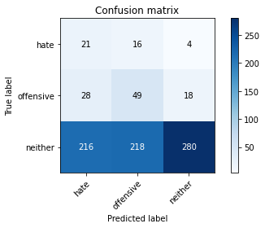

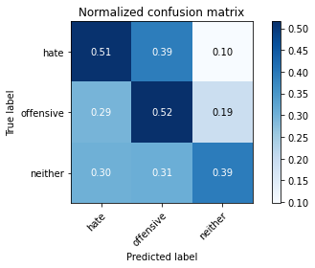

precision recall f1-score support

hate 0.08 0.51 0.14 41

offensive 0.17 0.52 0.26 95

neither 0.93 0.39 0.55 714

accuracy 0.41 850

macro avg 0.39 0.47 0.32 850

weighted avg 0.80 0.41 0.50 850

average eval_loss: 1.0976861805416818, accuracy: 0.4117647058823529

training 6 epoch...

3.9468162059783936 seconds used......

6 training finished! average train loss: 0.6822657383540097

total clf loss: 9.239744693040848 total adv loss: 1.1793864918872714

evaluating...

Confusion matrix, without normalization

[[ 19 17 5]

[ 23 54 18]

[182 196 336]]

Normalized confusion matrix

[[0.46341463 0.41463415 0.12195122]

[0.24210526 0.56842105 0.18947368]

[0.25490196 0.2745098 0.47058824]]

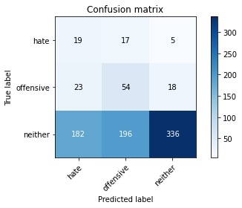

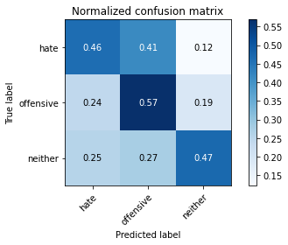

precision recall f1-score support

hate 0.08 0.46 0.14 41

offensive 0.20 0.57 0.30 95

neither 0.94 0.47 0.63 714

accuracy 0.48 850

macro avg 0.41 0.50 0.36 850

weighted avg 0.81 0.48 0.57 850

average eval_loss: 1.0224825722533604, accuracy: 0.4811764705882353

training 7 epoch...

3.944122314453125 seconds used......

7 training finished! average train loss: 0.44518810160019817

total clf loss: 6.55783611536026 total adv loss: 0.505180795211345

evaluating...

Confusion matrix, without normalization

[[ 28 9 4]

[ 33 47 15]

[286 188 240]]

Normalized confusion matrix

[[0.68292683 0.2195122 0.09756098]

[0.34736842 0.49473684 0.15789474]

[0.40056022 0.26330532 0.33613445]]

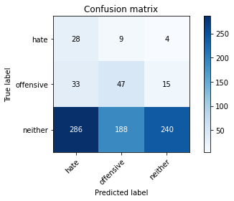

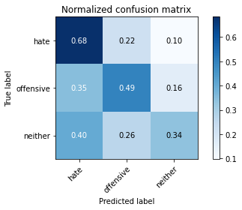

precision recall f1-score support

hate 0.08 0.68 0.14 41

offensive 0.19 0.49 0.28 95

neither 0.93 0.34 0.49 714

accuracy 0.37 850

macro avg 0.40 0.50 0.30 850

weighted avg 0.80 0.37 0.45 850

average eval_loss: 1.281815968973692, accuracy: 0.37058823529411766

training 8 epoch...

3.982605218887329 seconds used......

8 training finished! average train loss: 0.29460860964129953

total clf loss: 4.702271908521652 total adv loss: 0.1530372342094779

evaluating...

Confusion matrix, without normalization

[[ 30 7 4]

[ 36 40 19]

[280 168 266]]

Normalized confusion matrix

[[0.73170732 0.17073171 0.09756098]

[0.37894737 0.42105263 0.2 ]

[0.39215686 0.23529412 0.37254902]]

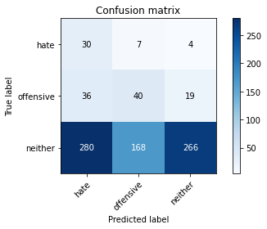

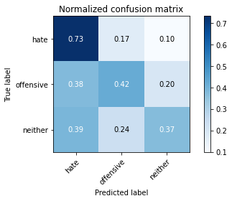

precision recall f1-score support

hate 0.09 0.73 0.16 41

offensive 0.19 0.42 0.26 95

neither 0.92 0.37 0.53 714

accuracy 0.40 850

macro avg 0.40 0.51 0.31 850

weighted avg 0.80 0.40 0.48 850

average eval_loss: 1.2772170062675032, accuracy: 0.3952941176470588

training 9 epoch...

3.964517116546631 seconds used......

9 training finished! average train loss: 0.19415544893811731

total clf loss: 2.970697820186615 total adv loss: 0.1649723977316171

evaluating...

Confusion matrix, without normalization

[[ 15 14 12]

[ 9 38 48]

[112 182 420]]

Normalized confusion matrix

[[0.36585366 0.34146341 0.29268293]

[0.09473684 0.4 0.50526316]

[0.15686275 0.25490196 0.58823529]]

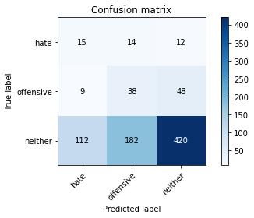

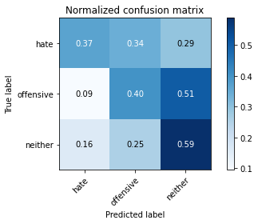

precision recall f1-score support

hate 0.11 0.37 0.17 41

offensive 0.16 0.40 0.23 95

neither 0.88 0.59 0.70 714

accuracy 0.56 850

macro avg 0.38 0.45 0.37 850

weighted avg 0.76 0.56 0.62 850

average eval_loss: 0.9840937751496948, accuracy: 0.5564705882352942

training 10 epoch...

3.9581398963928223 seconds used......

10 training finished! average train loss: 0.13684342297561028

total clf loss: 2.2833494767546654 total adv loss: 0.0214943509636214

evaluating...

Confusion matrix, without normalization

[[ 27 8 6]

[ 15 22 58]

[187 119 408]]

Normalized confusion matrix

[[0.65853659 0.19512195 0.14634146]

[0.15789474 0.23157895 0.61052632]

[0.26190476 0.16666667 0.57142857]]

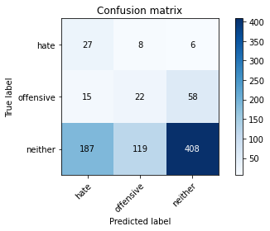

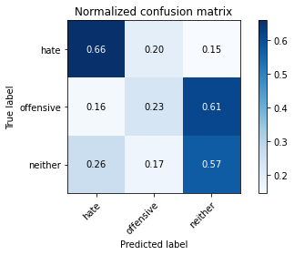

precision recall f1-score support

hate 0.12 0.66 0.20 41

offensive 0.15 0.23 0.18 95

neither 0.86 0.57 0.69 714

accuracy 0.54 850

macro avg 0.38 0.49 0.36 850

weighted avg 0.75 0.54 0.61 850

average eval_loss: 1.121432350818501, accuracy: 0.5376470588235294